**Eclipse ADT:**

Android Development Tools (ADT) is a Google-provided plug-in for the Eclipse IDE that is designed to provide an integrated environment in which to build Android applications. ADT extends the capabilities of Eclipse to let developers set up new Android projects, create an application UI, add packages based on the Android Framework API, debug their applications using the Android SDK tools, and export signed (or unsigned) .apk files in order to distribute their applications. It is free download. It was the official IDE for Android but was replaced by Android Studio (based on IntelliJ IDEA Community Edition).

**Procedure for Eclipse ADT Installation:**

1. Run the Eclipse Application in Eclipse ADT Bundle Folder.

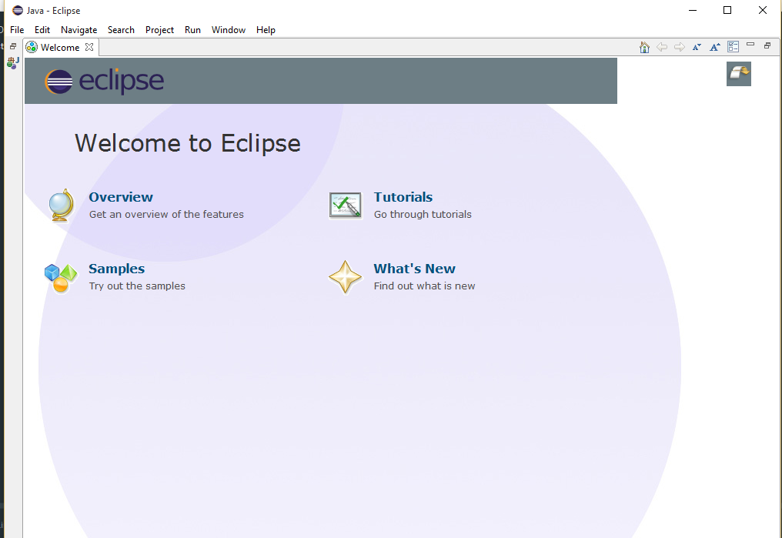

1. 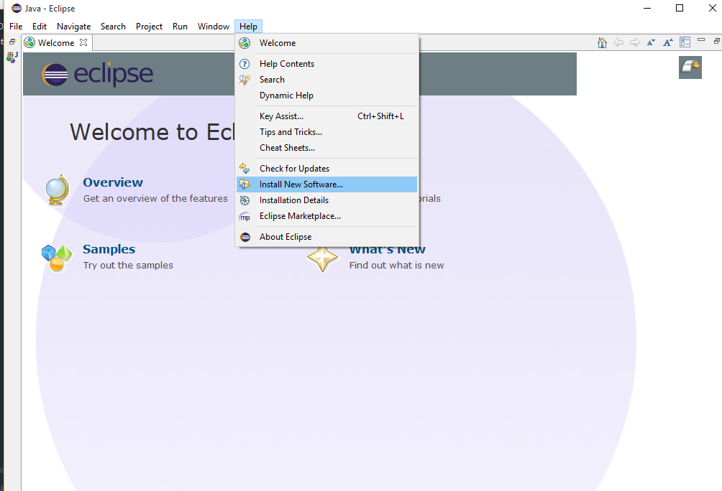Next Move to Help -> Install new Software
2. In the Install Software pane specify the address from which you need to download the software

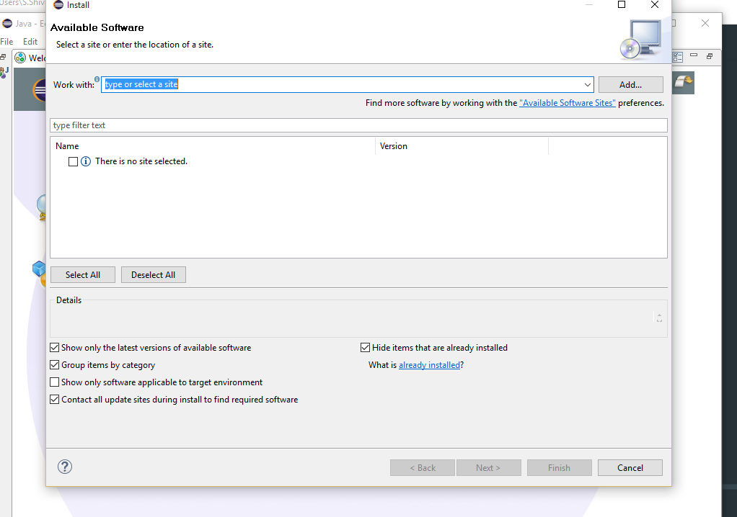

1. 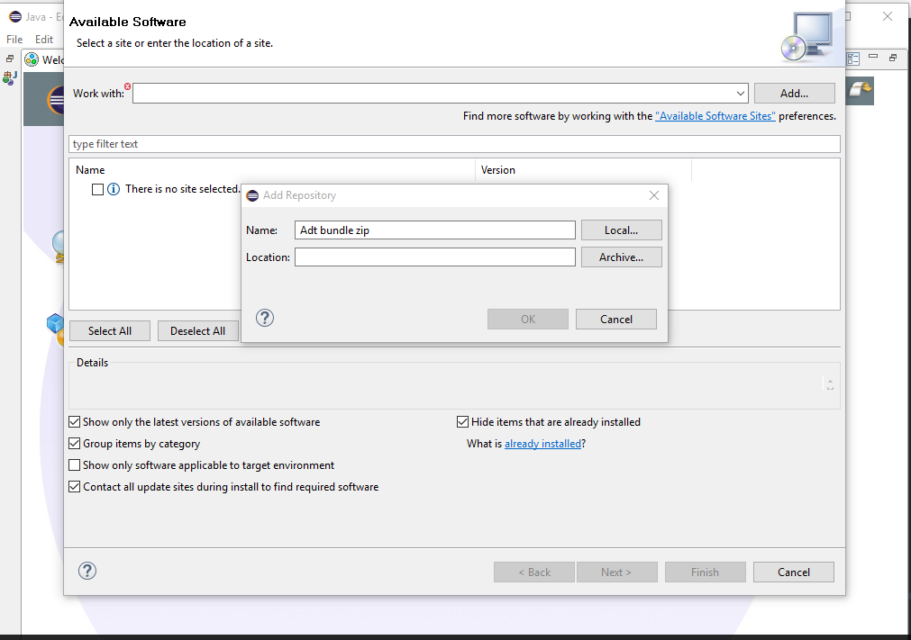Download the file as Zip file and proceed with available software pane.
2. Specify the address in location box and check all the items which are needed.

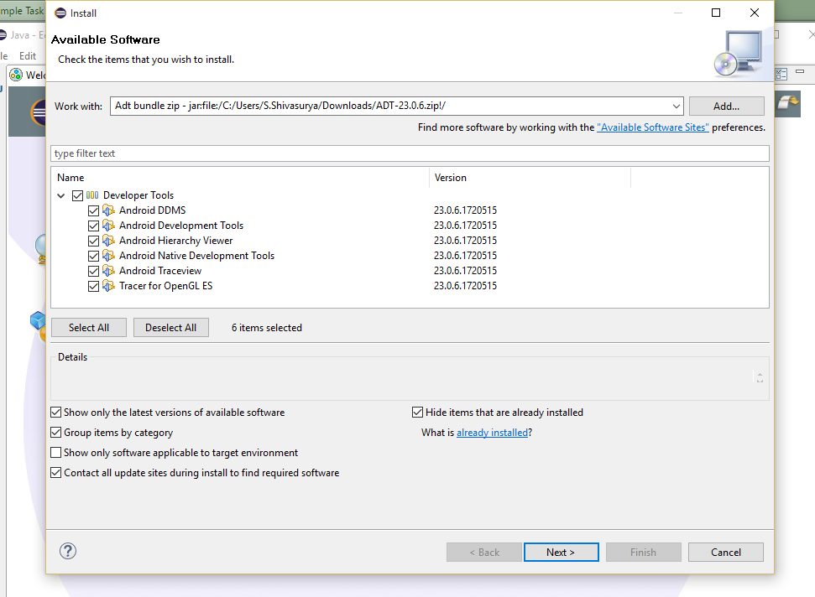

1. Accept the Terms and Conditions and then proceed with installation

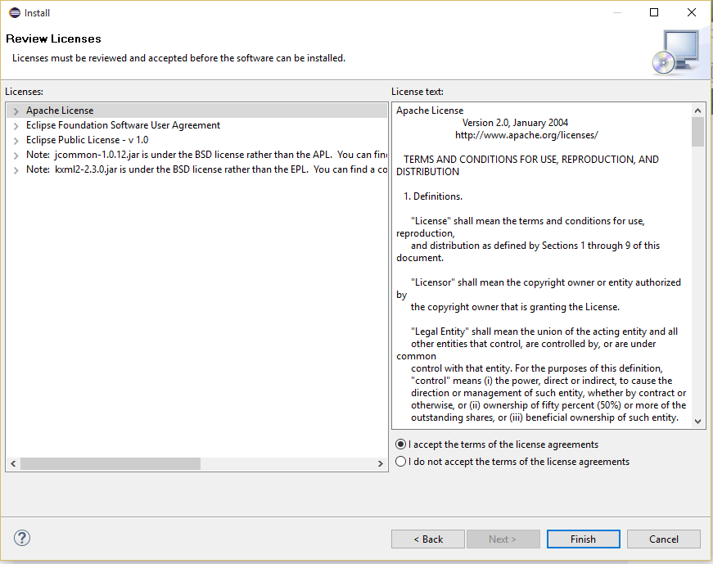

1. Install SDK appropriately from SDK manager

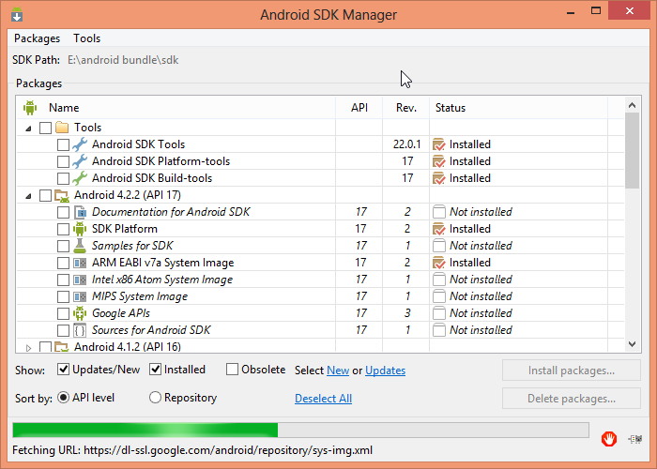

1. Click on File -> New Project, to create a new application project

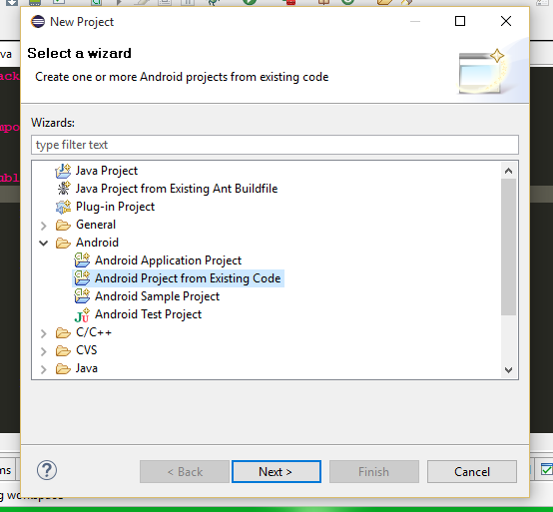

1. Specify the Project and Package name for the application

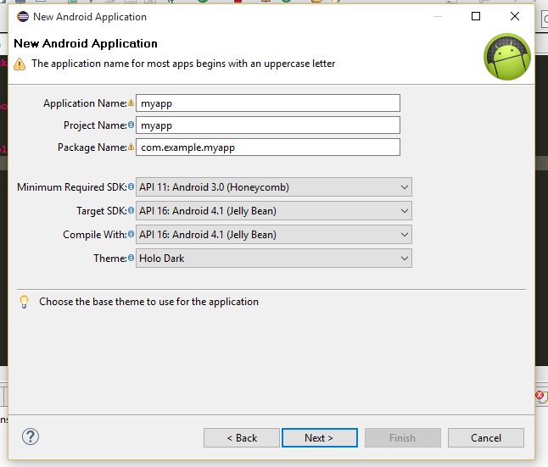

1. Specify the Project space for the new application to be created

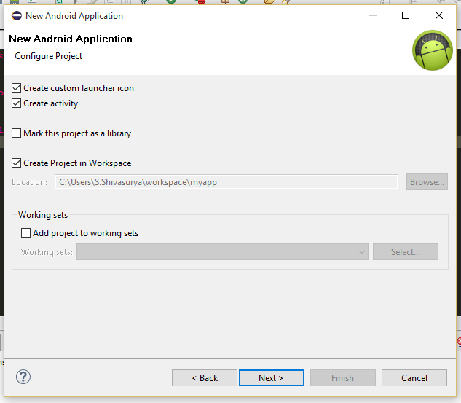

1. Configure the Launcher icon for the application to be done.

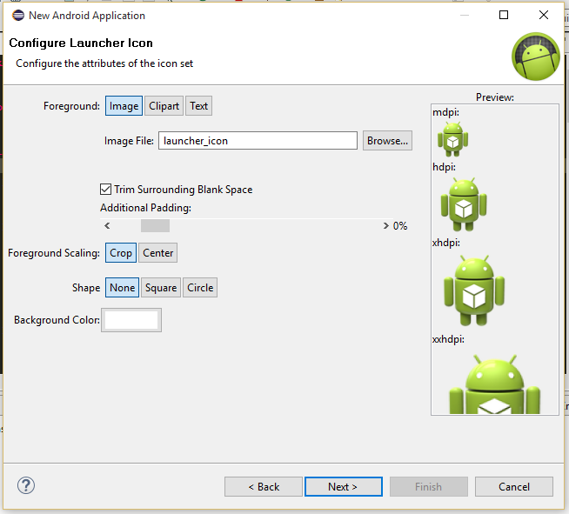

1. Select the type of activity what you have to create.

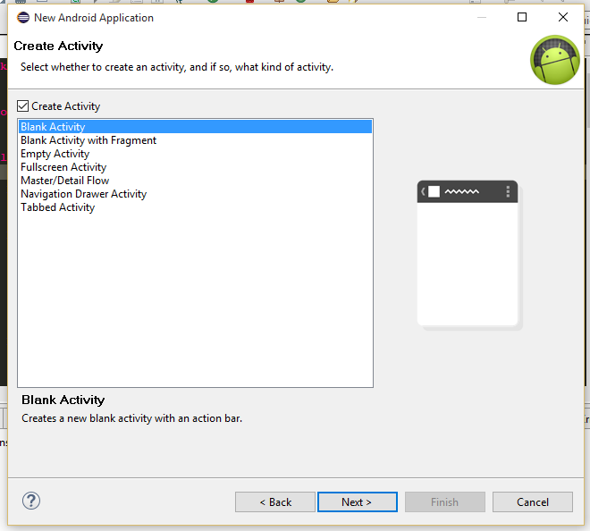

1. Specify the name for the activity

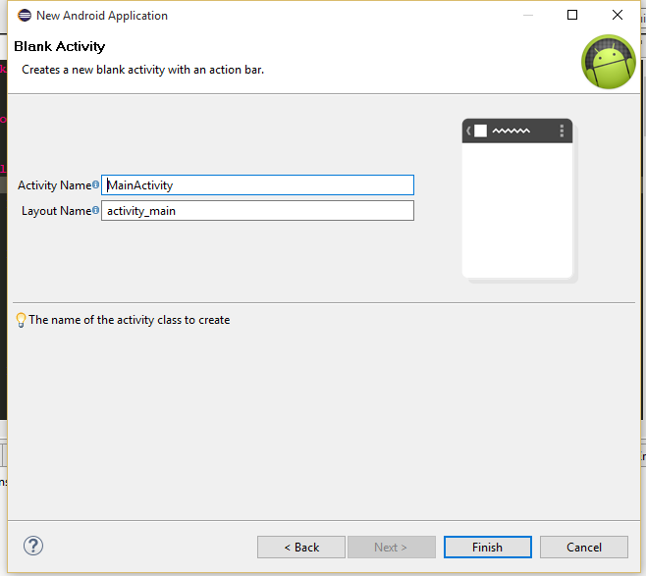

1. Now We have successfully completed the installation procedure and initiated a android application project successfully

